

Group Members:
MUHAMMAD MOIN DILDAR (211201) MUHAMMAD MAHMOOD GHAURI (211265) MUHAMMAD SALMAN (211291)

BE MECHATRONICS (Session 2021-2025)
Project Supervisor Engr. Umer Farooq
Lecturer

DEPARTMENT OF MECHATRONICS & BIOMEDICAL ENGINEERING FACULTY OF ENGINEERING
AIR UNIVERSITY, ISLAMABAD

i

FINAL YEAR PROJECT REPORT (SESSION 2021-2025)

DEPARTMENT OF MECHATRONICS & BIOMEDICAL ENGINEERING

Submitted By:
MUHAMMAD MOIN DILDAR (211201) MUHAMMAD MAHMOOD GHAURI (211265) MUHAMMAD SALMAN (211291)

Project Supervisor
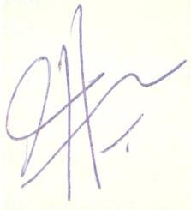

Engr. Umer Farooq
Lecturer
Chair Department

Dr. Noman Naseer

Acknowledgments

The successful completion of this project would not have been possible without the invaluable support and contributions of several individuals and entities.
We would like to express our sincere gratitude to Engr. Umer Farooq, our project supervisor, Dr. Hafiz Zia Ur Rehman, our project co-supervisor and all other faculty members for their continuous guidance, encouragement, and insightful feedback throughout the development process. Their expertise and support were instrumental in shaping this project.
We are also thankful to our team members, for their assistance and their contributions were crucial in this project. Furthermore, we would like to acknowledge DEPARTMENT OF MECHATRONICS & BIOMEDICAL ENGINEERING, for providing the resources and necessary support to carry out this project. This support played a vital role in ensuring the project's success.

Abstract

Nonintrusive load monitoring (NILM) systems serve to uncover the energy usage patterns of individual devices within an electrical system, yet expanding their market reach poses a significant hurdle. A novel approach to NILM, utilizing edge processing, is introduced, wherein energy consumption data undergo processing directly on the device installed within the monitored facility. Specifically, a neural network implemented on an Arm CortexM7 microcontroller is employed for this purpose. The NILM system is slated for installation on four everyday appliances in real-world scenarios. This report outlines a promising configuration aimed at facilitating the widespread adoption of NILM frameworks by reducing their implementation costs and complexity, while also addressing privacy concerns associated with cloud-based data processing. The outcomes of real-world testing in this endeavor are expected to provide compelling evidence of the potential of the proposed NILM framework across various applications, including smart homes, building automation, and industrial energy management.

Nomenclature
Symbol Abbreviation

A | Unit of Current
AI | Artificial Intelligence
ANN | Artificial Neural Network
CNN | Convolutional Neural Network
DL | Deep Learning
FHMM | Factorial Hidden Markov Model
flin | Linear Frequency
HMMs | Hidden Markov Models
Hz | Unit of Frequency
ILM | Intrusive Load Monitoring
Imax | Maximum Current
Inom | Normal Current
NILM | Non-Intrusive Load Monitoring
NN | Neural Network
RMS | Root Mean Square
V | Unit of Voltage
Vnom | Normal Voltage
Vmax | Maximum Voltage

Table of Contents

1.1 Background and Motivation 2
1.1.1 Sustainable Development Goals 2
1.2 Literature Review 2
1.3 Problem Statement 6
1.4 Objectives of the Project 6
1.5 Cost Analysis 6
1.6 Timeline of the Project 7
1.7 Work Division 7
1.8 Organization of Report 7
2.1 Description of the Project 8
2.2 Methodology 9
2.3 Product Specifications 11
2.3.1 Schematic Diagram 12
2.4 Preliminary Design and Calculations 12
3.1 Mathematical Modeling 13
3.2 Simulation Results 14
3.3 CAD Modeling 15
3.4 Algorithms 15
3.4.1 Flowcharts 15
4.1 Hardware Description 16
4.2 Components 16

List of Figures

Figure 1: Timeline of Project 7
Figure 2: Code Flow inform of Flow Chart 9
Figure 3: Block Diagram of NILM system 10
Figure 4: Block Diagram of System during Data Set collection phase 10
Figure 5: Schematic Diagram of System 12
Figure 6: Preliminary Design of Final Product 12
Figure 7: Simulink Model of NILM System 13
Figure 8: Simulink Model of ILM System 13
Figure 9: Simulink Model of NILM System Voltage-Current Output 14
Figure 10: Simulink Model of NILM System Power Output 14
Figure 11: Simulink Model of ILM System Voltage-Current Output 15
Figure 12: Simulink Model of ILM System Power Output 15
Figure 13: Hardware setup Installed for Data-Set Collection 16

List of Tables

Table 1: Cost Estimation 6
Table 2: List of Hardware Components 16

- Introduction
Energy management is a critical aspect of modern society, with increasing demands for efficient utilization of resources and sustainable practices. In response to this need, this project focuses on developing an AI-based energy monitoring embedded system. This system integrates advanced technologies such as Non-Intrusive Load Monitoring (NILM), Neural Networks (NN), and hardware components like the STM32 microcontroller and ARM processor. Today, it's really important for businesses and homes to keep an eye on how much energy they use. This project is all about helping with that. This project tends to create a smart system that can track energy use in real- time. In a world where everything costs money and resources are precious, it's really useful to know where the energy is consumed. This project isn't just about looking at numbers; it's about helping user to make better choices about how they use energy. With this system, user can see exactly where energy is being used, find ways to use less, and save money on energy bills. When humans use energy more carefully, pollution can be reduced and make the world a cleaner, healthier place for everyone.

Background and Motivation

Sustainable Development Goals
Today’s world is using more energy than ever, and it's hurting the environment. That's why we need smarter ways to track how much energy we're using.
The old way of monitoring energy was Intrusive Load Monitoring (ILM) which needs each monitoring device to be installed on every appliance, which could be challenging sometimes to be implemented practically. This project tackles that problem with an approach called Non-Intrusive Load Monitoring (NILM). In which a system can analyze overall energy usage and figure out how much each appliance is using by analyzing the input AC voltage signal, all without installing each monitoring device on each appliance.
NILM uses artificial intelligence (AI) to become a super-powered detective for energy usage. It can analyze energy usage in real-time, helping user understand where user can save money and be kinder to the environment. This project dives into the world of AI- powered NILM, exploring its potential to revolutionize how we manage energy

Literature Review
Since Hart [1] introduced the primary NILM framework during the 1980s, there have been huge progressions in the field. All through the accompanying twenty years, research basically centered around finding novel marks prepared to do precisely recognizing gadgets and creating classifiers to decipher these marks. This approach frequently involves recognizing occasions prior to classifying them. When an occasion is distinguished, the related machine's elements (and accordingly its mark) are separated. This technique can be broken down into three key stages: occasion recognition, include extraction, and burden ID. These procedures are normally sorted inside an occasion-based structure, where an "occasion" alludes to any adjustment of the electrical boundaries of the total sign.

Dong et al. [2] proposed a framework focused on distinguishing power signal occasions and their connected boundaries, including dynamic power range, receptive power range, consonant substance range, presence of spikes, number of stages, and occasion search time. The recognized occasions are then connected with machine functional cycles utilizing a bunching calculation. In [3], a comparative methodology is taken, connecting identified power signal occasions to machines by limiting contrasts across different boundaries, for example, successful voltage, compelling current, dynamic power, receptive power, obvious power, power factor, complete symphonious bending, and voltage-current direction. Over the long haul, endeavors have been pointed toward recognizing highlights extractable from occasions that empower exact machine separation while preferably staying predictable across various working circumstances. Thus, Teshome et al [4] disintegrated the total current into two symmetrical parts and characterized V-I directions comparative with every part.
Gupta et al. [5], further investigated this road by ceaselessly observing the electromagnetic obstruction impacts created by machines during their initiation or deactivation. Their framework processes the voltage estimated at a family attachment progressively to get its Fourier change. Post-handling uncovers a striking expansion in symphonic substance following machine exchanging occasions. Recognizable proof of the machine liable for the noticed symphonic substance is accomplished through a k-closest neighbor classifier. Essentially, in [6], the effect of turning procedure on the retained current sign was surveyed to create galvanically detached estimation frameworks. Be that as it may, these strategies share a few limits: Right off the bat, the adequacy of occasion location calculations is tested by the trouble in adjusting bogus up-sides and misleading negatives. Commotion in total power flags frequently clouds the distinguishing proof of minor burdens. While recently proposed occasion-based frameworks show remarkable execution because of precisely quantifiable post-occasion highlights, for example, those referenced prior, they display unfortunate speculation abilities, particularly when sent in concealed families or when prepared on information from different homes [7]. Furthermore, a considerable lot of these frameworks face computational difficulties that raise essentially with the quantity of burdens to be dis-collected, delivering them unrealistic for true applications [4].

Lastly, while many of these systems can detect appliance activities, they often lack the ability to provide quantitative insights into energy consumption. Non-intrusive acquisition of information regarding the status of various appliances holds significance in numerous applications where NILM systems find utility, including smart home automation and ambient assisted living. NILM systems serve to delineate the energy consumption patterns of individual appliances, potentially facilitating the development of recommendation systems.
Around 2010, a prominent shift arose in the domain of NILM frameworks research: the ascent of frameworks that sidestep the underlying occasion discovery stage. These frameworks work on a ceaseless stream of total sign examples (basically time-series information), handling them without hanging tight for explicit occasions. Named non- occasion-based frameworks, they take out the requirement for elements or marks, depending rather on the total power signal itself. Kolter et al. [8] were among the trailblazers in this field, presenting frameworks in light of discriminative meager coding for energy disaggregation. This technique includes preparing discriminative models for various machine classes, with individual energy utilization determined as a mix of essential capabilities increased by initiations.
Secret Markov models (Gee) have turned into a staple in non-occasion based NILM frameworks. Kim et al. [9] were early defenders, presenting a factorial Well (FHMM) where every machine's way of behaving is displayed freely. Following a preparation stage, the FHMM can gather machine states from the total utilization signal, empowering individual utilization division. In [10], Well are coordinated into a Bayesian structure, amalgamating different machine models into an exhaustive machine model. Bonfigli et al.
[11] proposed a bivariate FHMM utilizing both active and reactive power consumption data. Additionally, Paradiso et al. [12] exhibited that consolidating advantageous data like house inhabitance and machine use times can upgrade disaggregation results.
In 2015, Kelly and Knottenbelt [13] in presented the utilization of profound learning (DL) in non-occasion based NILM frameworks. While fake brain organizations (ANNs) had been used beforehand in NILM research, they were ordinarily utilized as classifiers in occasion-based frameworks' heap recognizable proof stages. [13] for the initial time, the total power signal was handled through an ANN utilizing moving-window handling, regarding the issue as a visually impaired source partition task. The creators exhibited that such designs beat combinatorial streamlining [8] and FHMM models [9], [10]. DL algorithms offer the benefit of computerizing highlight extraction, learning undertakings, for example, individual apparatus utilization, on-off state advances, and functional lengths straightforwardly from the information utilizing ANNs.
[14] Sense tracks your home's energy, it starts to perceive most apparatuses and different gadgets that utilization in excess of 60 watts. Normally the Sense screen identifies 12 gadgets in the principal month after it's introduced and 25-30 gadgets following a year. Each house is unique, notwithstanding, so the quantity of recognized gadgets might be sequential. Sense is intended for fast establishment and consistent improvement. The screen utilizes sensors that read the electrical flow north of 1 million times each second, while AI utilizes that information to figure out what gadgets are here and there.
[15] In this study, a Nonintrusive Load Monitoring (NILM) system leveraging edge processing is introduced, meaning to observe the energy utilization ways of behaving of individual gadgets inside an electrical arrangement. The proposed framework conducts energy utilization information handling straightforwardly on the gadget introduced inside the observed office. In particular, it embraces a succession to-point approach utilizing a convolutional brain network executed on an Arm CortexM7 microcontroller. Moreover, the paper presents discoveries from a broad year testing stage. The NILM framework was conveyed in two genuine homes in focal Italy to survey it’s down to earth sending and likely utility in true settings. This exploration offers a promising arrangement ready to work with the far-reaching reception of NILM frameworks, tending to worries in regards to execution expenses, intricacy, and protection related with cloud-based information handling. The results of true testing highlight the proposed NILM framework's possible across different spaces, including brilliant homes, building computerization, and modern energy the board.

Problem Statement

The current landscape of energy consumption monitoring lacks efficient real-time capabilities, often relying on intrusive hardware installations but that could be challenging to practically implement. To address this, there is a critical need for a non- intrusive load management system (NILM) powered by artificial intelligence (AI) that can accurately monitor energy consumption in real-time, including individual appliance energy usage.

Objectives of the Project

- Identification of Energy consumption of individual device from the selected group of daily use household appliances.
- Real Time Data collection (stored on server) and analyzation to predict the possible power consumption by a specific appliance.
- Implementing AI algorithm in Microcontroller.

Cost Analysis

Table 1: Cost Estimation
Item | No. of Items | Price
STM32 Nucleo Board | 1 | 5,300
ESP 32 | 3 | 3,450
Sensors | 5 | 11,700
SD Card Module | 2 | 300
RTC DS3231 | 2 | 1,300
Wires & Sockets |  | 7,700
Display & Other miscellaneous items |  | 2,250
Total |  | 32,000

Timeline of the Project

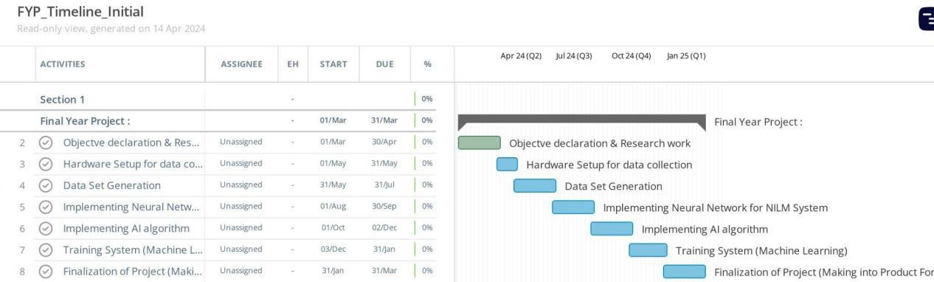
Figure 1: Timeline of Project

Work Division

- Research work, theoretical background and AI algorithm training & Implementation will be performed by MUHAMMAD SALMAN.
- PCB designing, hardware design and implementation Code implementation (for data set collection) will be performed by MUHAMMAD MAHMOOD GHAURI.
- Deployment of trained AI algorithm in microcontroller will be performed by MUHAMMAD MOIN DILDAR.

Organization of Report
In Chapter 1, an introduction is presented and discusses the background motivation to perform this project. Also mentioned the previous work done on technologies used in this project. Chapter 1 discusses why today’s world needs it and what objectives are to be achieved. Also, what cost and timeline required to do this project.
Chapter 2 discusses the final product specifications and approach used to achieve the above-mentioned objectives.

- Description

Chapter 1, the background, motivations, and already research related to AI-powered energy management systems had been studied, In Chapter 2, further searched on the project. Here, a detailed description of the system itself, outlining the methodology behind its development, product specifications, and a preliminary schematic diagram. And also delve into the design considerations and initial calculations that will guide the project's implementation.

Description of the Project

This project aims to monitor energy consumption using smart technology called Non- Intrusive Load Monitoring (NILM) Using Artificial Intelligence (AI). The main goal of this device is to help businesses and households to keep track of their energy usage in a simple and efficient way. The project consists of several components, including the design of the monitoring system, the integration of NILM and AI technologies using STM32 Nucleo board (NUCLEO-H750VBT6), ESP 32, sensors (Smart Samaan single phase energy metering module) and Display. The device works by analyzing overall energy consumption data to identify patterns associated with specific appliances or behaviors, without the need for intrusive methods like installing sensors on individual devices. It helps businesses and homes to save money by finding ways to reduce their energy usage and to protect the environment by promoting energy-saving practices that reduce pollution and save resources and it makes energy monitoring easier for everyone, so more people can manage their energy usage better.

Methodology

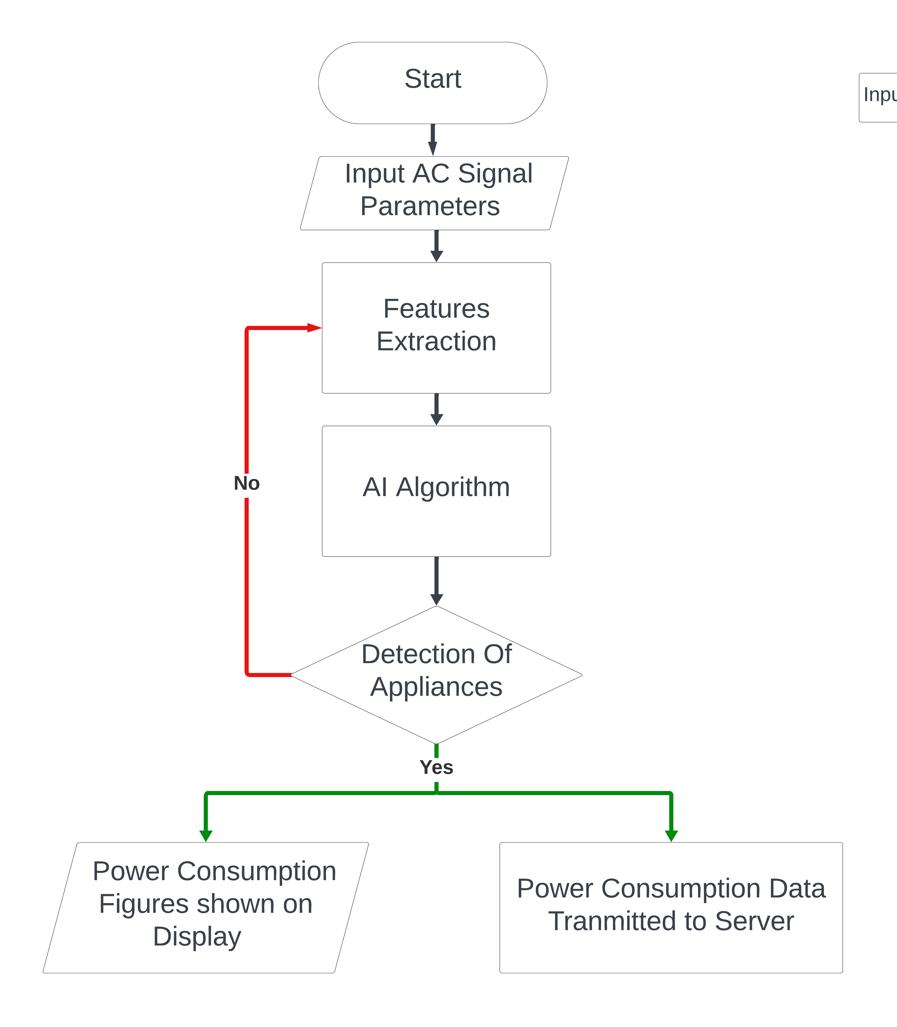
Figure 2: Code Flow inform of Flow Chart

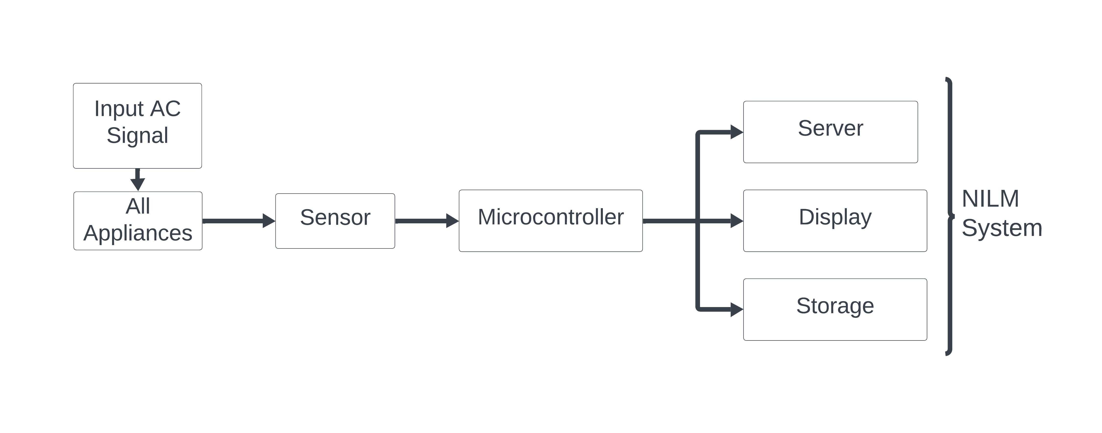
Figure 3: Block Diagram of NILM system

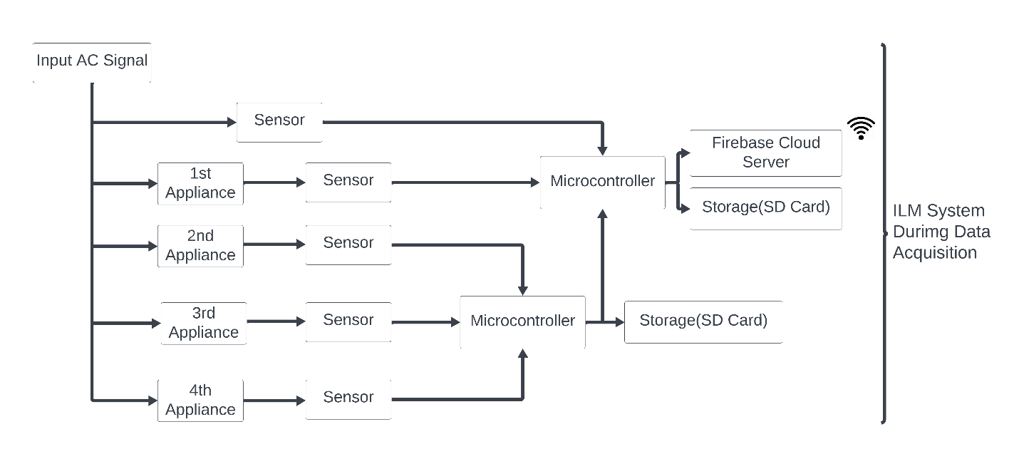
Figure 4: Block Diagram of System during Data Set collection phase

In Figure 2, flow of code is represented in the form of flowchart. The system will extract feature and AI algorithm by using these features detects which appliance is consuming energy and the results will be shown on display. Also results will be transmitted to wireless monitoring station.

In Figure 4, the system is shown in block diagram form during data set generation where the system will act as an intrusive load monitoring system in which signal from each appliance will be stored in a storage device and overall signal of combined load of input will be analyzed and stored.
In Figure 3, the final product is shown on block diagram level in which system will be Non-Intrusive Load Monitoring system. The system will only analyze input signals and through Energy Disaggregation technique, energy consuming device and energy consumption by each device will be detected.

Product Specifications

Here, the list of features and operational specifications of our project is mentioned.

- Real-Time Monitoring: The device provides up-to-date information on energy consumption, permitting users to path usage patterns as they occur.
- Non-Intrusive Operation: Using Non-Intrusive Load Monitoring (NILM) technology, the system analyzes overall power consumption without the need for intrusive hardware installation.
- AI Integration: By including Artificial Intelligence, the device can identify individual appliance usage patterns and provide insights for monitor and display.
- User-Friendly Interface: The device features a simple interface that permits users to easily access and illuminate energy usage data.
- Environmental Sustainability: It helps protect the environment by promoting energy- saving practices that reduce pollution and save resources and it makes energy monitoring easier for everyone, so more people can manage their energy use better

Schematic Diagram

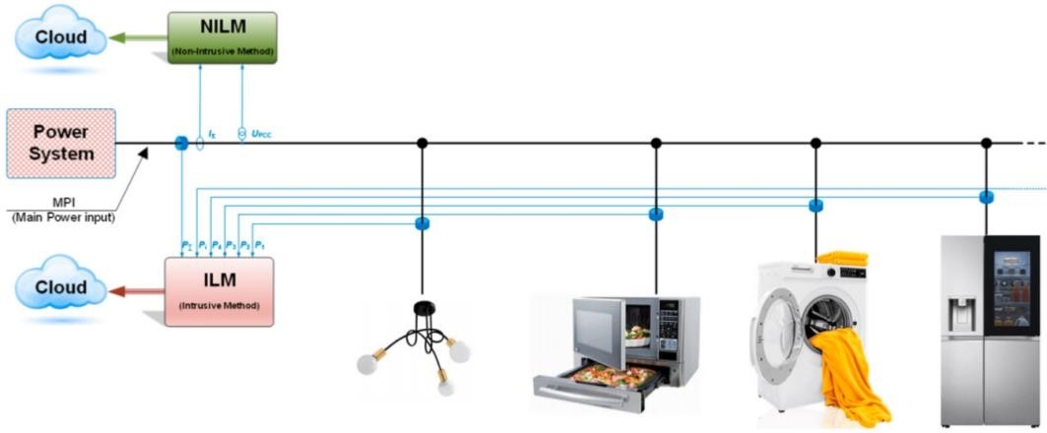
Figure 5: Schematic Diagram of System

During Data set collection phase ILM System will be implemented and In final product NILM system will be implemented.

Preliminary Design and Calculations
- V_{max} = 840 V_{peak}
- I_{max} = 43 A
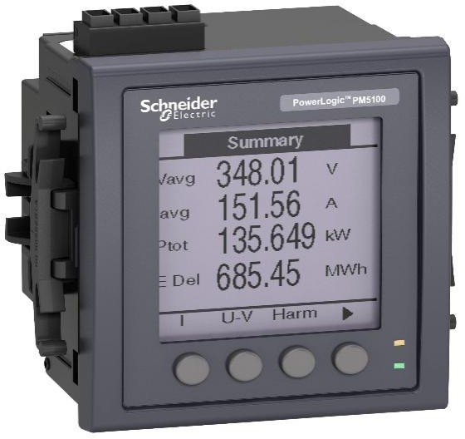
Figure 6: Preliminary Design of Final Product

- Modeling & Simulation

Mathematical Modeling
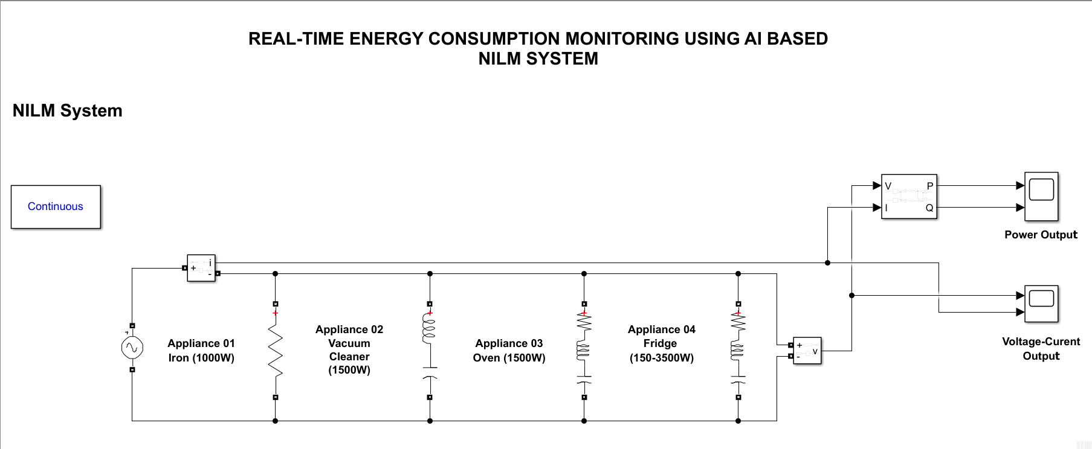
Figure 7: Simulink Model of NILM System
Figure 10 represent the modeling of NILM system in Simulink. In this model AC voltage source is used as input source, also in order to represent appliances we used four RLC series. To Measure Voltage & Current, Current measurement block & Voltage measurement block is used and power block is used to measure active and reactive power is used. The Output Voltage, Current, Active and Reactive Power is shown on Scope.

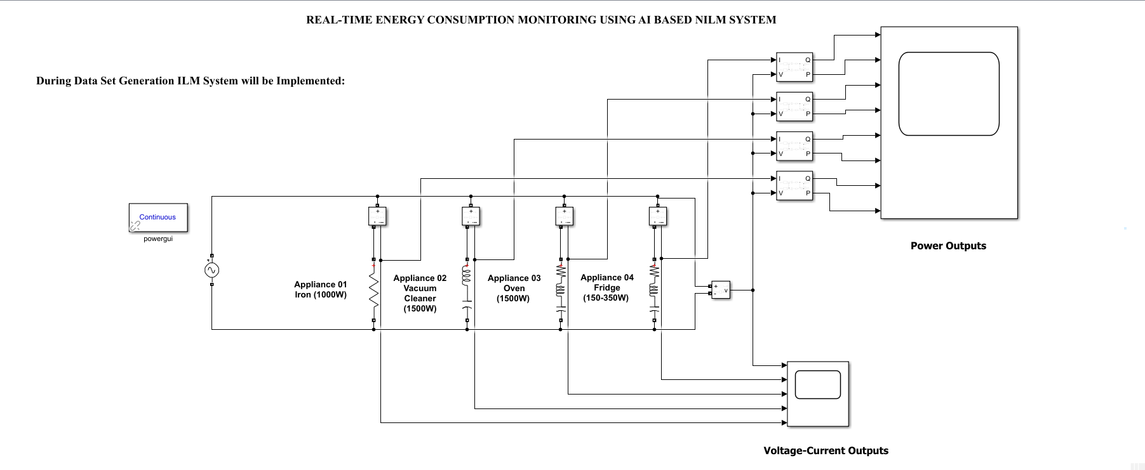
Figure 8: Simulink Model of ILM System
Figure 11 represent the modeling of ILM system in Simulink. In this model AC voltage source is used as input source, also in order to represent appliances we used four RLC series. To Measure Voltage & Current, Current measurement block & Voltage measurement block is used and power block is used to measure active and reactive power is used. The Output Voltage, Current, Active and Reactive Power is shown on Scope.

Simulation Results
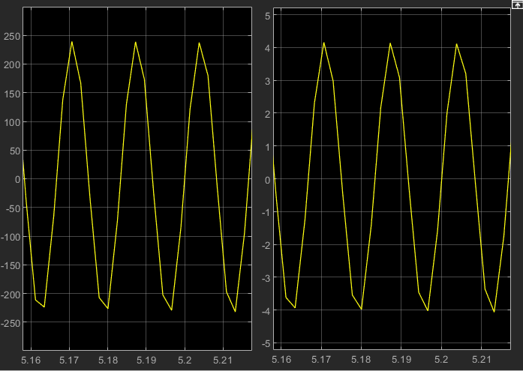
Figure 9: Simulink Model of NILM System Voltage-Current Output
Figure 12 represent the voltage-current output of NILM system model in Simulink. The left graph shows the voltage sensed by sensor and right graph shows the current sensed by sensor.

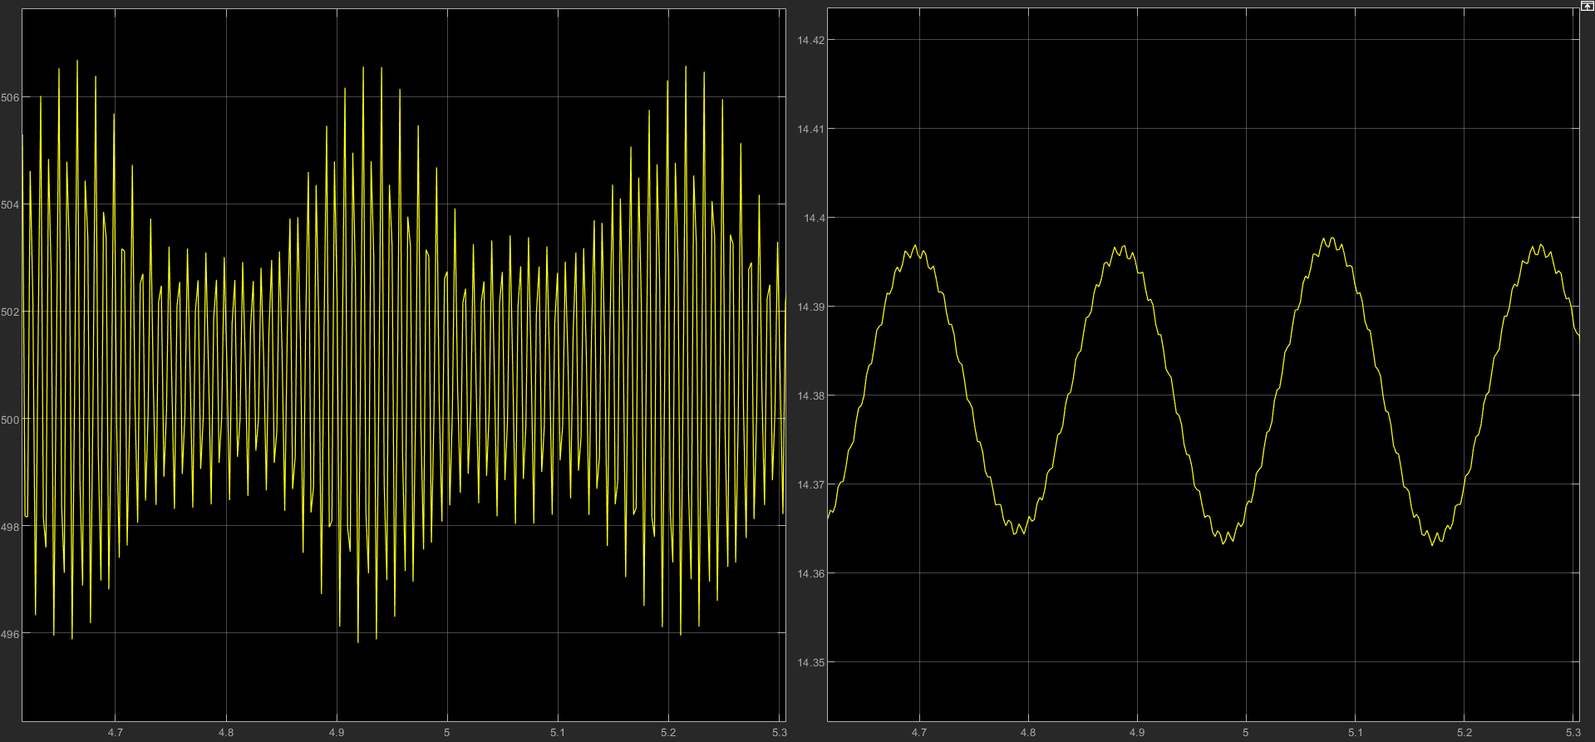
Figure 10: Simulink Model of NILM System Power Output
Figure 13 represent the power output of NILM system model in Simulink. The left graph shows the active power sensed by sensor and right graph shows the reactive power sensed by sensor.

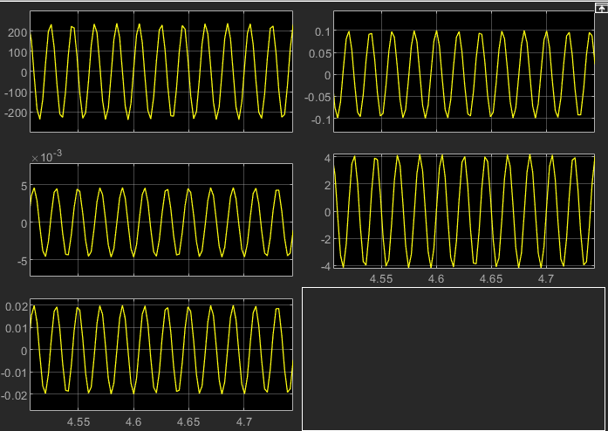
Figure 11: Simulink Model of ILM System Voltage-Current Output
Figure 14 represent the voltage-current output of ILM system model in Simulink. The Top left graph shows the voltage sensed by sensor and other graphs show the current of each appliance sensed by sensor.

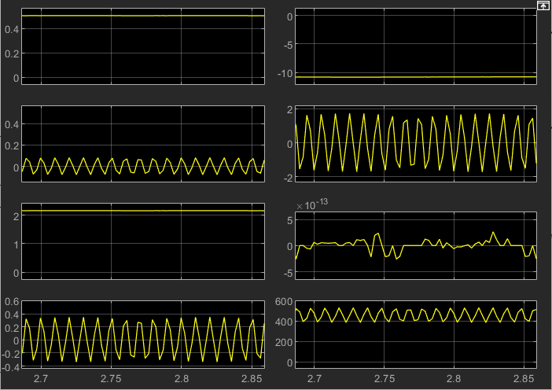
Figure 12: Simulink Model of ILM System Power Output
Figure 15 represent the power output of ILM system model in Simulink. The left graphs show the reactive powers of each appliance sensed by sensor and right graphs show the active powers of each appliance sensed by sensor.

CAD Modeling

Algorithms

Flowcharts

- Experimental Setup

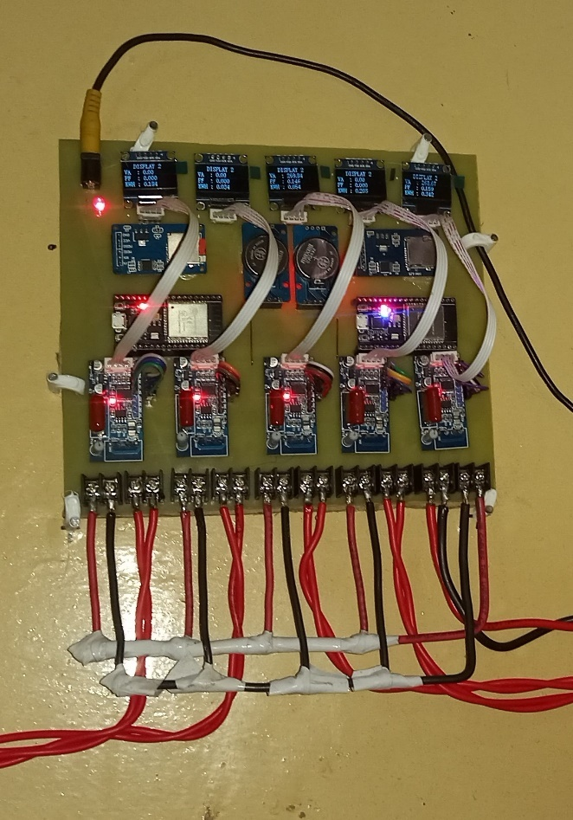
Figure 13: Hardware setup Installed for Data-Set Collection

Hardware Description

For data set collection ILM system is implemented in which each sensor is reading the features of each appliance. Also, one sensor is reading features of input AC supply. These sensors are serially transmitting features to ESP32s and then ESP32s are storing these features in SD card & cloud based Firebase database. Real time clock module to get unix timestamp for dataset.

Components
Table 2: List of Hardware Components
Single Phase Energy Metering Module | 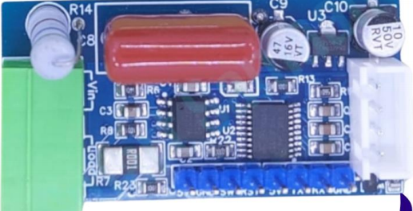
ESP32 | 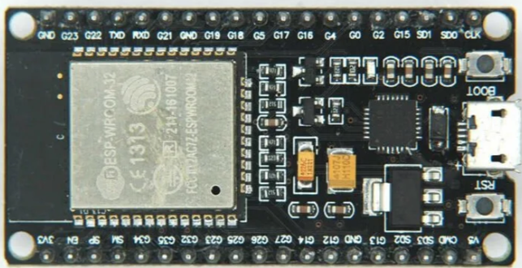
RTC DS3231 | 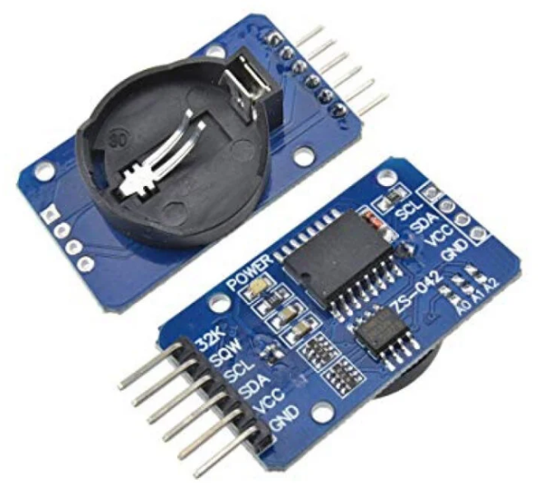
SD Card Module | 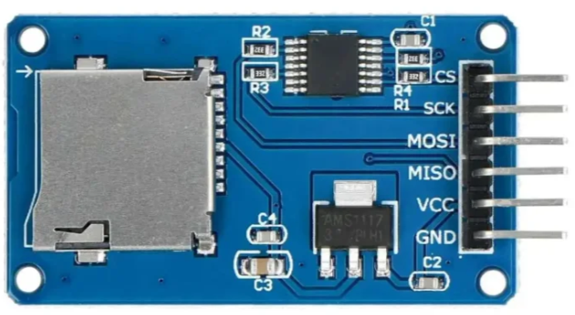
OLED Display | 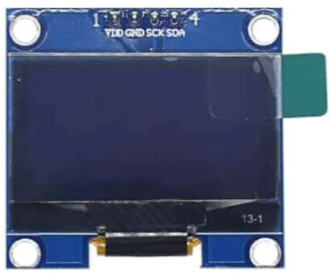
5V, 2A DC Supply Charger | 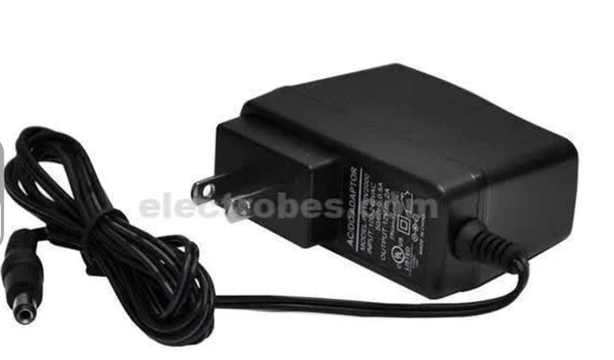
Wires (3/29, 7/29) | 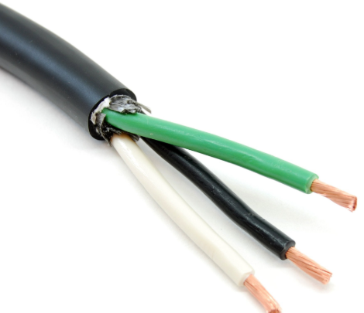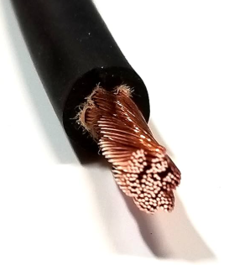

Bibliography

[1] | G. Hart, "Prototype Nonintrusive Appliance Load Monitor," Electric Power Research  Institute, Vrginia, 1985.
[2] | M. Dong, P. C. Meira, W. Xu and C. Y. Chung, "Non-intrusive signature extraction for major residential loads," IEEE Transactions on Smart Grid, vol. 4, no. 3, pp. 1421-1430,  2013.
[3] | G. Bucci, F. Ciancetta, E. Fiorucci and S. Mari, "Load Identification System for Residential Applications Based on the NILM Technique," in 2020 IEEE International Instrumentation and Measurement Technology Conference (I2MTC), Dubrovnik, 2020.
[4] | D. F. Teshome, T. D. Huang and K. L. Lian, "Distinctive load feature extraction basedon fryzes time-domain power theory," IEEE Power and Energy Technology Systems  Journal, vol. 3, no. 2, pp. 60-70, 2016.
[5] | S. Gupta, M. S. Reynolds and S. N. Patel, "Electrisense: single-point sensing using emi for electrical event detection and classification in the home," in Proceedings of the 12th ACM International Conference on Ubiquitous Computing, New York, ACM, 2010, pp.  139-14.
[6] | G. Bucci, F. Ciancetta, E. Fiorucci, S. Mari and A. Fioravanti, "Measurements for non- intrusive load monitoring through machine learning approaches," Acta IMEKO, no. 10,  pp. 90-96, 2021.
[7] | S. Dash and N. C. Sahoo, "Electric energy disaggregation via non-intrusive load monitoring: A state-of-the-art systematic review," Electric Power Systems Research, vol.  213, 2022.
[8] | J. Z. Kolter, S. Batra and A. Y.-T. Ng, "Energy disaggregation via discriminative sparse coding," in 23rd International Conference on Neural Information Processing Systems,  Vancouver, 2010.
[9] | H. D. Kim, M. Marwah, M. Arlitt, G. Lyon and J. Han, "Unsupervised disaggregation of low frequency power measurements," in Proceedings of the 2011 SIAM International  Conference on Data Mining, New York, 2011.
[10] | O. Parson, S. Ghosh, M. Weal and A. Rogers, "Non-intrusive load monitoring using prior models of general appliance types," in National Conference on Artificial Intelligence,  Toronto, 2012.
[11] | R. Bonfigli, E. Principi, . M. Fagiani, M. Severini, S. Squartini and F. Piazza, "Non- intrusive load monitoring by using active and reactive power in," Applied Energy., vol.  208, pp. 1590-1607, 2017.
[12] | F. Paradiso, F. Paganelli, D. Giuli and S. Capobianco, "Context-based energy disaggregation in smart homes," Future Internet, vol. 8, no. 1, 2016.
[13] | J. Kelly and W. Knottenbelt, "Neural NILM: Deep Neural Networks Applied to Energy Disaggregation," in 2nd ACM International Conference on Embedded Systems for Energy-Efficient Built Environments (BuildSys '15), is the Association for Computing  Machinery (ACM)., New York, 2015.

[14] | Sense, "Sense Energy Monitor," Sense, January 2022. [Online]. Available:  https://sense.com/.
[15] | S. Mari, . G. Bucci, . F. Ciancetta, . E. Fiorucci and A. Fioravanti, "An Embedded Deep Learning NILM System," in IEEE Transactions on Instrumentation and Measurement,  L’Aquila, 2023.

